**Lab # 07**

**OBJECT**

***Step by step Installation of CentOS and managing services in CentOS***

**LAB TASK:**

# Step 1: Prepare a host and install CentOS 8 VM in VirtualBox

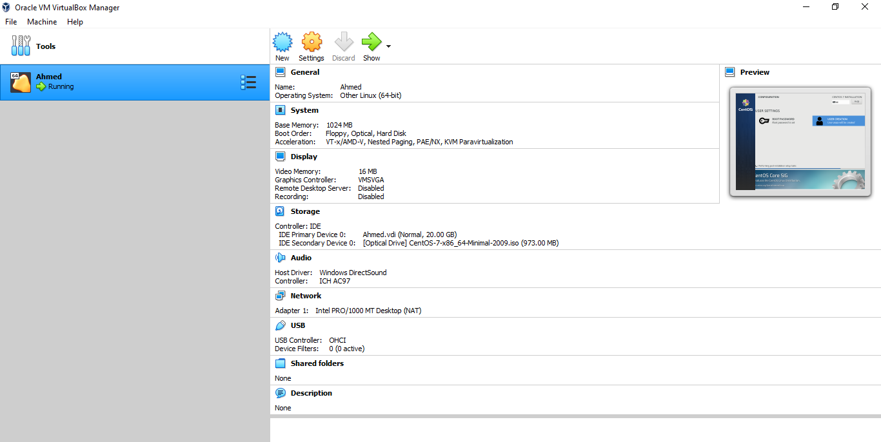

# Step 2: Create a new VM in VirtualBox with your name

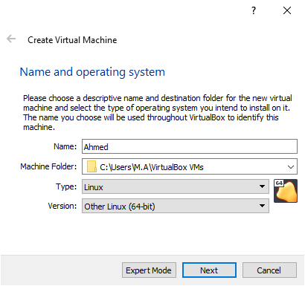

Step 3: **Allocate 1024MB RAM to your VM**

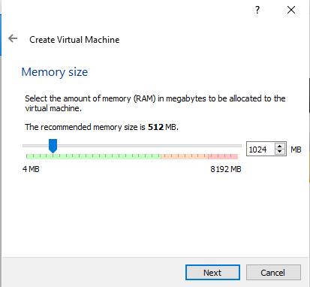

# Step 4: Add Virtual Hard Disk to the new VM in VirtualBox

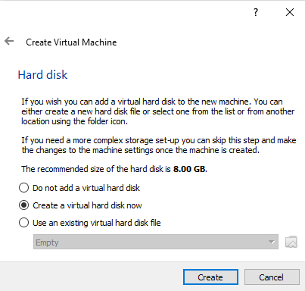

# Step 5: Choose the type of file that you would use for the VHD

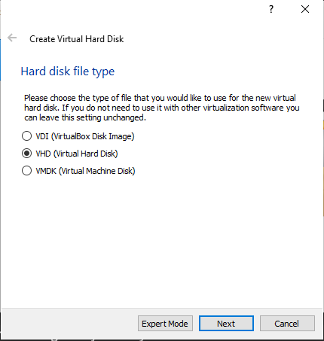

# Step 6: Select the Storage for your Physical Hard Disk

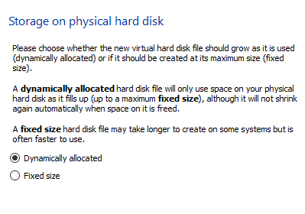

# Step 7: Choose the file location and set the disk size to 20 GB

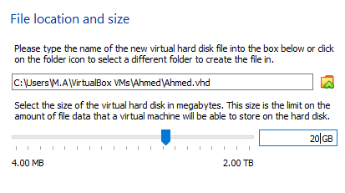

# Step 8: Prepare a host and install CentOS 8 VM in VirtualBox

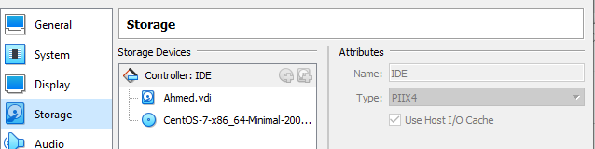

# Step 9: Go to settings in VirtualBox, select storage and select the ISO image

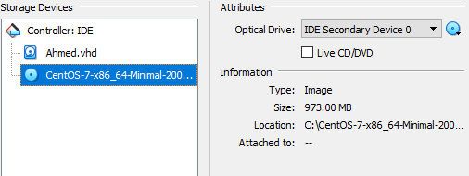

# Step 10: Go to settings in VirtualBox, select the Bridge Adapter

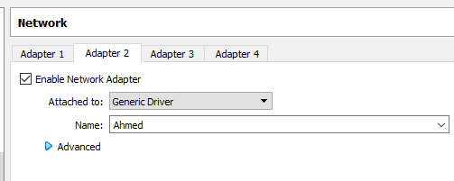

# Step 11: Go to Systems in VirtualBox, select the dual processor

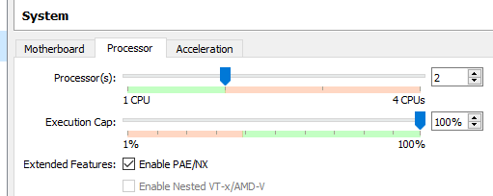

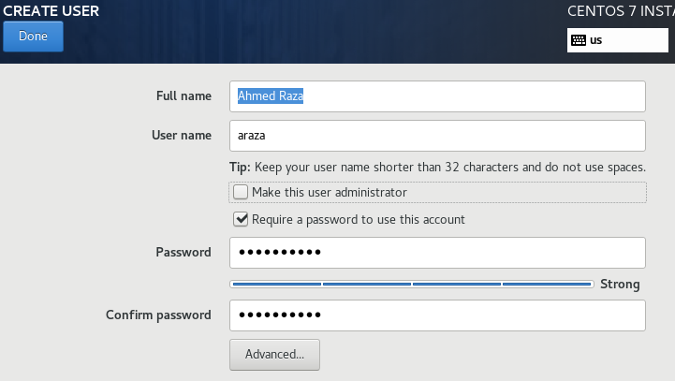

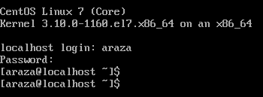

## Installing Apache on CentOS

### Step 1: Update Software Versions List

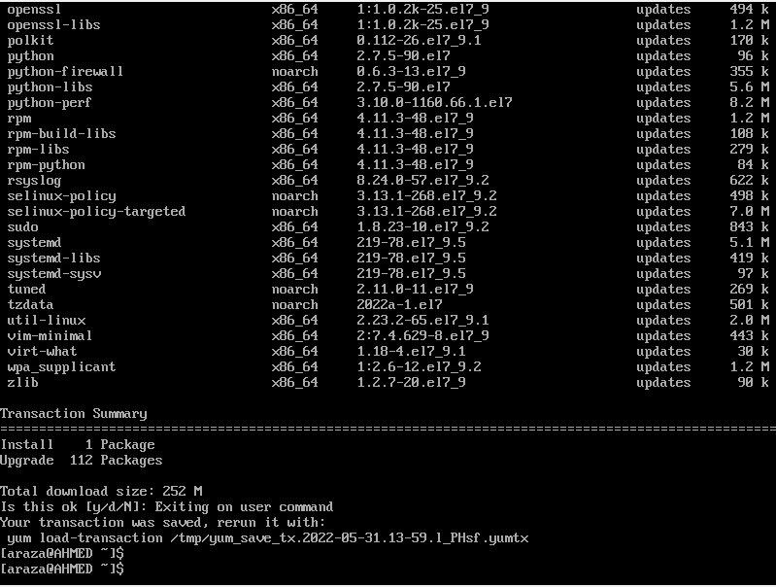

### Step 2: Install Apache

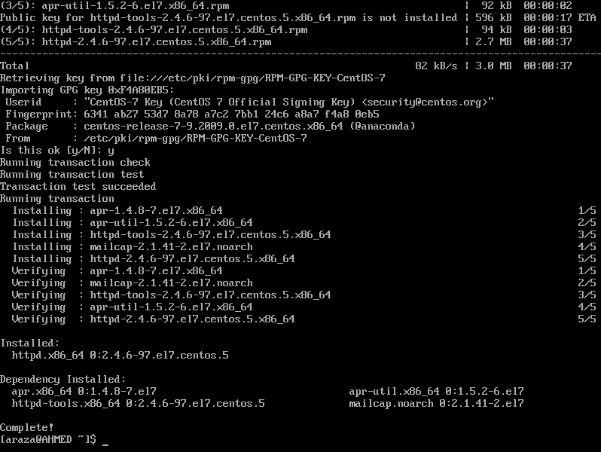

### Step 3: Activate Apache

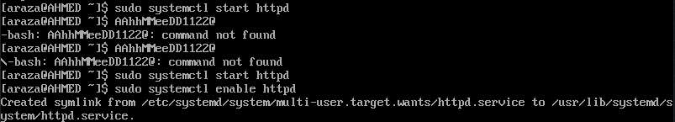

### Step 4: Verify Apache Service

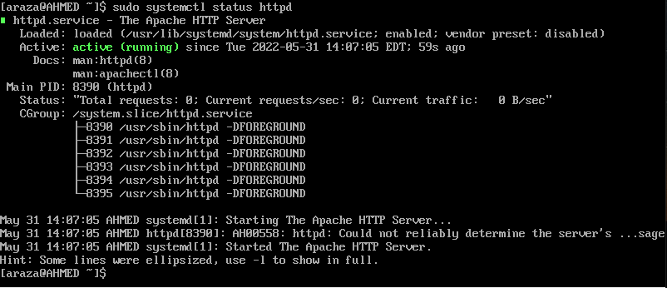

### Step 5: Configure firewalld to Allow Apache Traffic

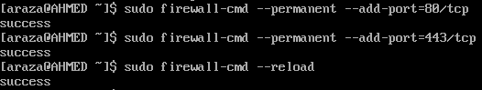

Q1: Command to List all the files in the current directory and their sizes:use multiple columns and mark special files

 ls -S (the S is uppercase)

Q2: Command to List the contents of directories /bin and /etc.

ls -l /etc /bin

Q3: Command to Display your current directory.

pwd command

Q4: List the contents of the root directory.

ls command

Q5: Create a directory testdir in your home directory.

